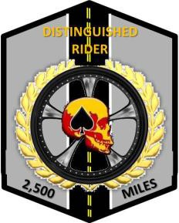
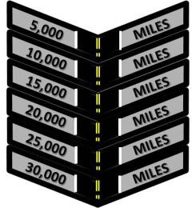
Combat Veterans Motorcycle Association (CVMA) Tennessee Chapter 18-4
Distinguished Rider Program (DRP)
V1.0 (September 2018)
The Distinguished Rider Program (DRP) has been developed to serve two important functions at the chapter level. The first of these is to serve as an incentive program to encourage CVMA members to participate in their chapter rides and events. Secondly, the DRP serves an important role in rewarding and recognizing those CVMA riders and passengers who steadfastly participate in their chapter rides/events and camaraderie rides. Riding and camaraderie are founding principles of successful and enjoyable CVMA chapters. The DRP is a useful tool to help strengthen and grow our Chapters.

The Distinguished Rider patch is in the shape of a hexagon and is 2.5 inches wide and 3.25 inches tall. It has a grey background and black border. The center of the patch contains a vertical two-lane road.
Beneath the CVMA skull in the center of the patch is a motorcycle wheel and tire surrounded by a gold wreath. The words “DISTINGUISHED RIDER” are contained at the top of the patch. The patch is awarded for the completion of 2500 miles ridden.

The Distinguished Rider chevrons have a grey background and black border. The center of the chevron contains a vertical two-lane road that is in line with the base patch. As subsequent chevrons are earned and affixed under the patch, the road appears longer to signify the lengthening journey. The first chevron is awarded at 5,000 miles, the next at 10,000 miles, and so on at 5,000-mile increments.

DRP Guidelines:

- Eligibility
  - $10 application fee is required for each rider and passenger, before any miles can be logged.
  - The patch and chevrons may be awarded to:
    - Motorcycle Rider
    - Motorcycle Passenger
    - Driver of Chapter support vehicle on long-distance rides where a support vehicle is deemed necessary by the CEB/Chapter. If the support vehicle changes drivers in the course of that trip, only those miles driven by each driver can apply to that driver.

- Allowable Mileage
  - The mileage is earned and accumulated from:
    - A CVMA group ride at any in or out of state Chapter level or higher ride to include miles ridden on motorcycle to and from State, Region, or National meeting/rally. Miles will be recorded from home of record in 201 file to event starting location (round trip). For a single rider, a CEB member of the hosting chapter is to sign DRP Ride sheet. Then, on the reverse side of log sheet, their positions, title and annotate number of miles for their event.
    - When three (3), operating separate motorcycles, or more members conduct a camaraderie ride (min 50 miles round trip).
    - Mileage will be logged from home of record to any Chapter Meetings, Chapter link up points, and other group events deemed to be chapter-sponsored. (must be riding motorcycle)
    - Miles ridden in support of a veteran funeral escorts and/or viewings.
      - If only one member, then the miles calculated will be from home of record in 201 file to funeral home, the escort route, and return home.
      - If more than one member, the miles calculated will be from the link up location to the funeral home, the escort route, and return to link up point.

      - Log

- The Chapter Treasurer or the designated DRP point of contact (POC) will:
  - Maintain mileage logs from all events
  - Maintain and update accumulated mileage log totals as necessary
  - Maintain all DRP applications
- The ride Road Captain, Chapter Officer, or ride lead (camaraderie rides) will:
  - Maintain a log for each DRP member to sign in
  - Record the total miles for the route with start and end points
  - Turn in completed ride log into the DRP POC.
- Each rider and passenger is responsible for checking in and signing riding log at each event.

      - Patches and Chevrons
        - The first patch price will be covered from the application fee; any further chevrons will be purchased out of the Chapter Funds to the Chapter Treasurer.
        - Each calendar year the DRP member with the most miles ridden during that year will be awarded with a Road Warrior certificate.
        - Any replacement patches will be purchased by the DRP member.

Example DRP Sign in Log

CVMA 18-4 DISTINGUISHED RIDER PROGRAM (DRP) SIGN IN
Date: |  | Distance: 10+ | = | Event:
Road Capt/Rep: Start Location
 |  |  | End Location
TYPE | NUMBER | NAME | Application Date | Signature
1 | FM1940 | Lex Luther | 7/13/2014
2 | FM007 | James Bond | 7/13/2014
3 | LM1963 | Dr Who | 7/13/2014
5 | FM1995 | Xena | 7/13/2014
6 | AUX1995 | Gabrielle | 7/13/2014
Example DRP Program Log

Master Rollup (Accumulated Miles)

COUNT | NUMBER | NAME | Application Date | TOTAL | 2016 | 2017 | 2018 | Patch Issued | 5  K | 1  0  K | 1  5  K | 2  0  K
1 | FM1940 | Lex  Luther | 7/13/2014 | 9019 | 7279 | 510 |  | 5/7/15 | X
2 | FM007 | James  Bond | 7/13/2014 | 4566 | 4230 | 0 |  | 1/6/16
3 | LM1963 | Dr Who | 7/13/2014 | 4227 | 3891 | 0 |  | 4/4/16
5 | FM1995 | Xena | 7/13/2014 | 1758 | 1533 | 225
6 | AUX1995 | Gabrielle | 7/20/2014 | 5174 | 5174 | 0 |  | 12/5/16 | X

Yearly Ride Log (Each Event)

COUNT | NUMBER | NAME | Application Date | TOTAL | 2/4/17  Funeral Escort | 2/18/17  Lex’s archenemy ride | 3/13/2017  PreMeeting Ride
1 | FM1940 | Lex Luther | 7/13/2014 | 510 | 122 | 285 | 103
2 | FM007 | James Bond | 7/13/2014 | 0
3 | LM1963 | Dr Who | 7/13/2014 | 0
5 | FM1995 | Xena | 7/13/2014 | 225 | 122 |  | 103
6 | AUX1995 | Gabrielle | 7/20/2014 | 0

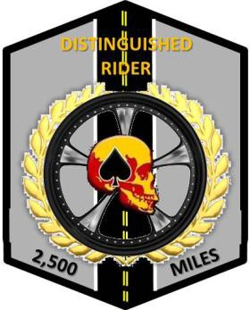

Combat Veterans Motorcycle Association
Tennessee Chapter 18-4
Distinguished Rider Program Application

Date:

Rider Name: | Member Number:
Mailing Address: | Email:
City/State/Zip: | Phone:

☐ | Full Member | ☐ | Auxiliary Member | ☐ | Support Member | ☐ | Other Member

Application Fee | Paid | Date
$10 | ☐

Signature of Officer Approving Application:
Title of Officer: | Date of Approval:

Date: | Officer Signature
2,500 mile Patch awarded
5,000 mile Patch awarded
10,000 mile Patch awarded
15,000 mile Patch awarded
20,000 mile Patch awarded
25,000 mile Patch awarded
30,000 mile Patch awarded

